Dave Jhared G. Paduada
BSCpE IV – GF

CPE22 – Digital Signal Processing
Prelims

Signal | - Convey information from one point to another (They may be generated by electronic means, or by some natural means such as talking, walking, your heart beating, an earthquake, the sun heating the sidewalk)  - described by a function of one or more independent variables. The value of the function (i.e., the dependent variable) can be real-valued scalar quantity a complex-valued quantity or perhaps a vector.  Examples:  $$s_{1}\left(t\right)=Asin 3πt$$  $$s_{2}\left(t\right)=5t$$  $$s_{3}\left(t\right)=5t^{2}$$  $$s_{4}\left(x, y\right)=3x+2xy+10y^{2}$$  $$s_{5}\left(t\right)=Ae^{j3πt}=Acos 3πt+jAsin 3πt$$  $$S_{6}\left(t\right)=\left[\begin{matrix} s_{1}\left(t\right) \\ s_{2}\left(t\right) \\ s_{3}\left(t\right)\end{matrix}\right]$$
System | - process signals to produce a modified or transformed version of the original signal  - defined as a physical device that performs an operation on a signal.  - Example. A filter used to reduce the noise and interference corrupting a desired information-bearing signal is called a system.
Signal Processing | - the operation on or analysis of signals, or measurements of time-varying or spatially varying physical quantities.
Basic Elements of a Digital Signal Processing System
Most of the signals encountered in science and engineering are analog in nature. That is, the signals are functions of a continuous variable, such as time or space, and usually take on values in a continuous range. Such signals may be processed directly by appropriate analog systems (such as filters, frequency analyzers, or frequency multipliers) for the purpose of changing their characteristics or extracting some desired information.

Analog Signal Processing | Analog output signal  Analog signal processor  Analog input signal  In such a case we say that the signal has been processed directly  in its analog form, as illustrated in figure above. Both the input signal and the output signal are in analog form.
Digital Signal Processing System | Analog input signal  D/A converter  Digital Signal Processor  A/D converter  Analog input signal  Digital output signal  Digital input signal  There are many reasons why digital signal processing of an analog signal may be preferable to processing the signal directly in the analog domain, as mentioned briefly earlier. First, a digital programmable system allows flexibility in reconfiguring the digital signal processing operations simply by changing the program.  Digital signals are easily stored on magnetic media (tape or disk) without de-  terioration or loss of signal fidelity beyond that introduced in the A/D conversion.  One practical limitation is the speed of operation of A/D converters and digital signal processors. We shall see that signals having extremely wide bandwidths require fast-sampling-rate A/D converters and fast digital signal processors. Hence there are analog signals with large bandwidths for which a digital processing approach is beyond the state of the art of digital hardware.
Multichannel and Multidimensional Signals | As explained in Section 1, a signal is described by a function of one or more inde- pendent variables. The value of the function (i.e., the dependent variable) can be a real-valued scalar quantity, a complex-valued quantity, or perhaps a vector. For example, the signal:  s₁(t) = A sin 3πt  in real-valued signal. However, the signal  s₂ (t) = Ae^{j3πt} = A cos 3πt + j A sin 3πt  is complex valued.  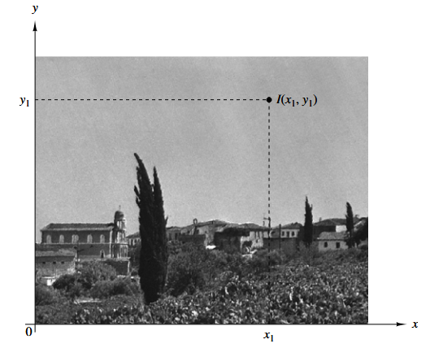  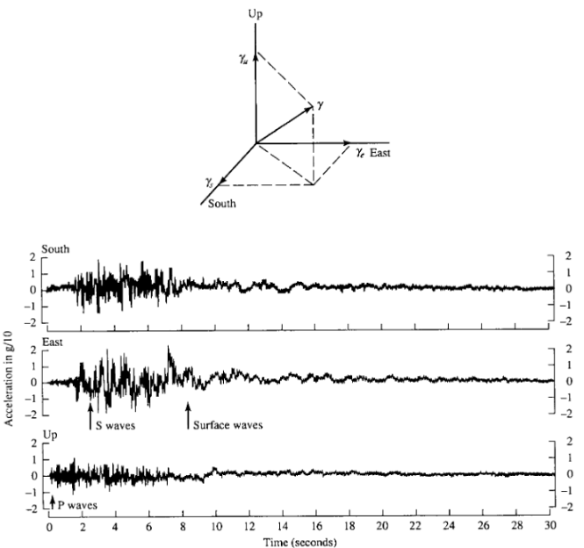  In some applications, signalrs are generated by multiple sources of multiple sensors. Such signals, in turn, can be represented in vector form. Figure below shows the three components of a vector signal that represents the ground accelaration due to an earthquake.  This acceleration is the result of three basic types of elastic waves. The primary (P) waves and the secondary (S) waves propagate within the body of rock are longitudinal and transversal, respectively. The third type of elastic wave is called the surface wave, because it propagates near the ground surface. If S_{k} (t), k = 1, 2, 3, denotes the electrical signal from the kth sensor as a function of time, the set of p = 3 signals can be represented by a a vector S₃ (t), where  $$S_{3}\left(t\right)= \left[\begin{aligned}\begin{aligned}S_{1}\left(t\right) \\ S_{2}\left(t\right)\end{aligned} \\ S_{3}(t)\end{aligned}\right]$$  We refer to such a vector of signals as a multichannel signal.In electrocardiography, for example, 3-lead and 12-lead electrocardiograms (ECG) are often used in practice, which result in 3-channel and 12-channel signals.
Continuous-Time Versus Discrete-Time Signals
Signals can be further classified into four different categories depending on the characteristics of the time (independent) variable and the values they take.
Continuous Time Signals | Or analog signals are defined for every value of time and they take on values in the continuous interbal (a, b), where  a can be -∞ &  b can be ∞.  Mathematically, these signals can be described by functions of a continuous variable.  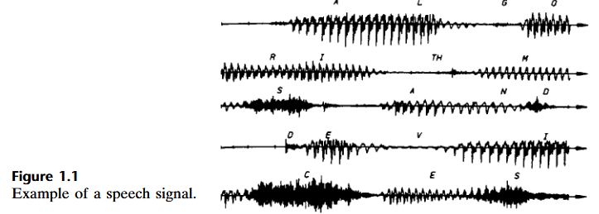
Discrete-time signals | 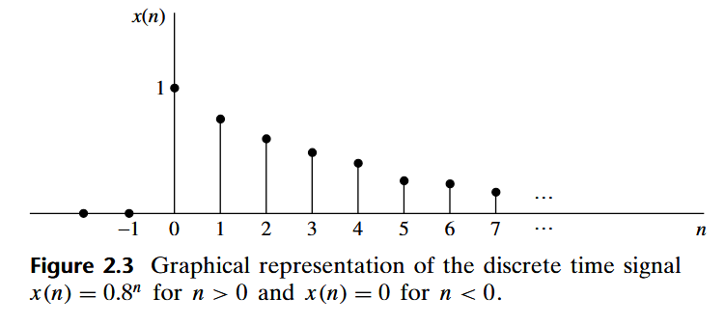  Are defined only at certain specific values of time. These time instants need not be equidistant, but in practice they are usually taken at equally spaced intervals for computational convenience and mathematical tractability.
Continuous-Valued Versus Discrete-Valued Signals
The values of a continuous-time or discrete-time signal can be continuous or discrete
Continuous-Valued signal | If a signal takes on all possible values on a finite or an infinite range.
Discrete-Valued signal | If the signal takes on values from a finite set of possible values.
Deterministic Versus Random Signals
The mathematical analysis and processing of signals requires the availability of a mathematical description for the signal itself. This mathematical description, often referred to as the signal model, leads to another important classification of signals.
Deterministic | Any signal that can be uniquely described by an explicit mathematical expression, a table of data, or a well-defined rule is called deterministic. This term is used to emphasize the fact that all past, present, and future values of signals are known precisely, without any uncertainty.
Random | The lack of such a relationship implies that such signals evolve in time in an unpredictable manner. We refer to these signals as random. The mathematical framework for the theoretical analysis of random signals is provided by the theory of probability and stochastic process.
Discrete Time Signals
A discrete-time signal x(n) is a function of an independent variable that is an integer. It is graphically represented in the figure before. It is important to note that a discrete-time signal is not defined at instants between two successive samples. Simply, the signal x(n) is not dfined for noninteger values of n.

Besides the graphical representation of a discrete-time signal or sequence, there are some altenrative representations that are often more convenient to use. These are:
Functional representation | $$x\left(n\right)= \left\{\begin{aligned}1, for n=1, 3 \\ 4, for n=2 \\ 0, elsewhere\end{aligned}\right.$$
Graphical representation | Graphically represented as  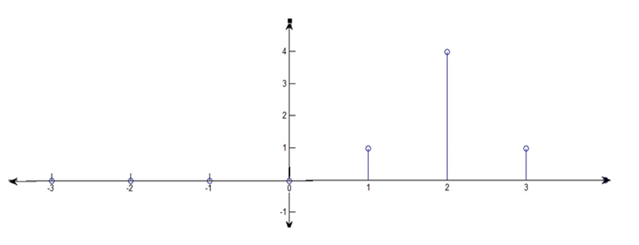  Okay, let’s imagine we have a sequence of numbers, and we want to represent them in a certain way. In this case, we’re looking at a graph where each position in the graph represents a specific value for a number, like a list of points.  Now, in this special kind of representation, we start by putting the number '1' in certain spots on the graph. Specifically, we put '1' at positions where n=1, n=2, and n=3. So, the first three spots in the graph will all have the value '1'.  Next, at position n=2, we’re going to put a '4' instead of '1'. This is like saying, “Hey, at this specific spot on the graph, the number is special and should be 4 instead of 1.”  Finally, for all the other positions on the graph that aren’t mentioned, we’ll just leave them as '0'. So, if there’s a spot for n=4, n=5, and so on, those values will be '0', which basically means “nothing” or “no signal” in this case.
Tabular representation | n … -2 -1 0 1 2 3 4 5  x(n) … 0 0 0 1 4 1 0 0
Sequence representation | 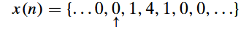  An infinite-duration signal or sequence with the time origin (n = 0) indicated by the symbol $↑$ is represented as  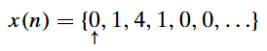  A sequence x(n), which is zero for n < 0, can be represented as  The time origin for a sequence x(n), which is zero for n<0, is understood to be the first (leftmost) point of the sequence.  A finite-duration sequence can be represented as  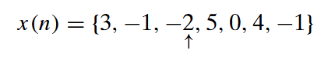  whereas a finite-duration sequence that satisfies the condition x(n) = 0 for n < 0 can be represented as  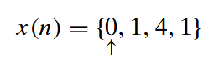  The signal consists of seven samples or points (in time), so it’s called or identified as a seven-point sequence. Similarly, the sequence given by the figure above is a four point sequence.
Seatwork

Give the graphical , tabular, and sequential representation of the given functional representation.
$$x\left[n\right]=\left\{\begin{aligned}1+\frac{n}{3} \\ 1 \\ 0\end{aligned}\right.\begin{matrix}, \\ , \\ ,\end{matrix}\begin{matrix} -3≤n≤-1 \\ 0≤n≤3 \\ elsewhere\end{matrix}$$

Graphical | 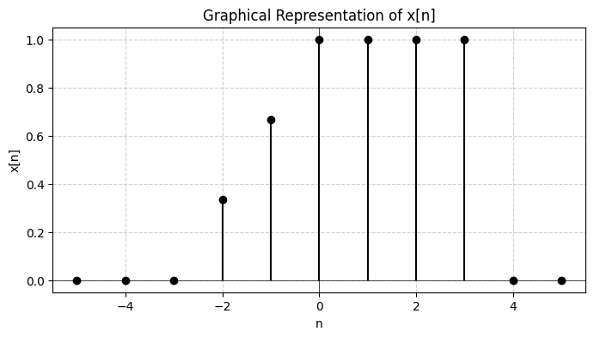  In this activity, we represented the discrete-time signal x[n] both graphically and numerically based on its functional definition. The signal was defined piecewise: for −3 ≤ n ≤ −1, the values followed the expression 1 + $\frac{n}{3}$​, producing a gradually increasing sequence from 0 to 0.67. For 0 ≤ n ≤ 3, the values were constant at 1, forming a flat portion of the signal. Outside these ranges, the signal was zero. Using these conditions, we plotted the stem graph to clearly show the amplitude of each discrete value of nnn, while also preparing the tabular and sequential representations to verify the correctness of the functional description. This step-by-step process allowed us to fully interpret and visualize the behavior of the signal.
Tabular
Sequence Representation
Unit Sample Sequence | The unit sample sequence is denoted as δ(n) and is defined as  In words, the unit sample sequence is a signal that is zero everywhere, except  at n = 0 where its value is unity. This signal is sometimes referred to as a unit  impulse. In contrast to the analog signal δ(t), which is also called a unit impulse  and is defined to be zero everywhere except at t = 0, and has unit area, the  unit sample sequence is much less mathematically complicated.  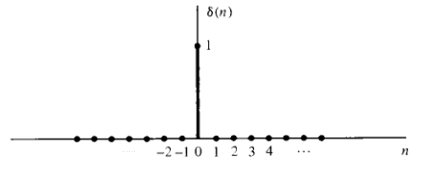
Unit Step Signal | The unit step signal is denoted as u(n) and is defined  Graphical representation of the unit step signal:  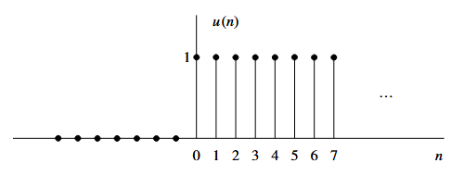
Unit Ramp Signal | The unit ramp signal is denoted as u r (n) and is defined as  Graphical representaiton of unit ramp signal  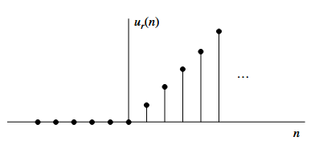
Exponential Signal | A sequence of the form $x\left[n\right]=a^{n} for all n$  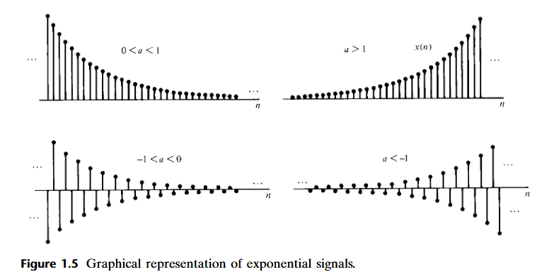  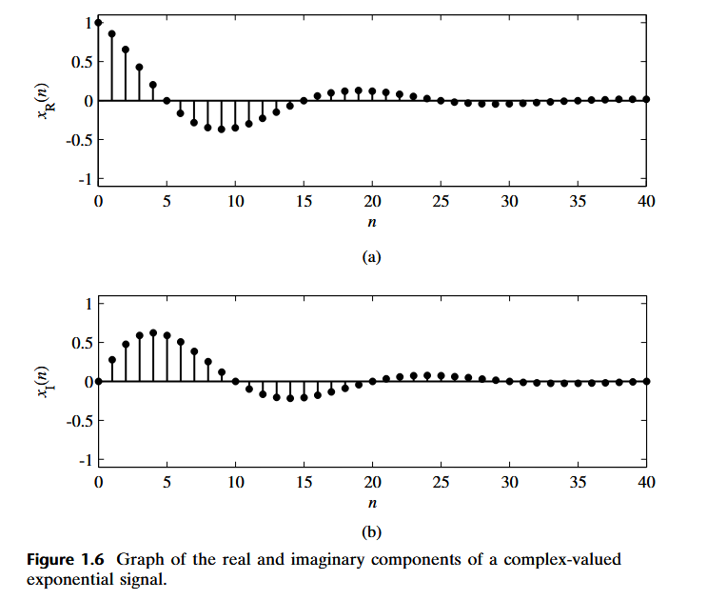  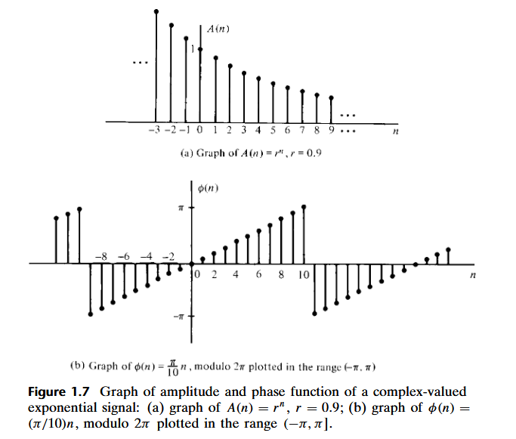
Classification of Discrete Time Signals | The mathematical methods employed in the analysis of discrete-time signals and systems depend on characteristic of signals.
Energy Signals | $$E=\sum_{n=-∞}^{∞}{{\left|x(n)\right|}^{2}}$$  We have used the magnitude-squared values of x(n), so that our definition applies to complex-valued signals as well as real-valued signals. The energy of a signal can be finite or infinite. If E is finite (i.e., 0 < E < ∞), then x(n) is called an energy signal. Sometimes we add a subscript x to E and write E x to emphasize that Ex is the energy of the signal x(n).
Power Signal | Many signals that possess infinite energy have a finite average power. The aver-  age power of a discrete-time signal x(n) is defined as  $$P=\lim_{N→∞}{\frac{1}{2N+1}}\sum_{n=-∞}^{∞}{{\left|x(n)\right|}^{2}}$$  If we define the signal energy of x(n) over the finite interval −N ≤ n ≤ N as  $$E=\lim_{N→∞}{E_{N}}$$  then we can express the signal energy E as  $$\boxed{P=\lim_{N→∞}{\frac{1}{2N+1}}E_{N}}$$  Clearly, if E is finite, P = 0. On the other hand, if E is infinite, the average  power P may be either finite or infinite. If P is finite (and nonzero), the signal is  called a power signal. The following example illustrates such a signal.
Sample Problems

 | Determine the power and energy of the unit step sequence.
 | Find the power and signal energy of $x\left[n\right]={\left(\frac{1}{4}\right)}^{n}u[n]$
 | Find the power and signal energy of $x\left[n\right]=\sin\left(\frac{πn}{3}\right)$.
 | Find the power and signal energy of$x\left[n\right]=\cos\left(\frac{πn}{2}\right)$.
 | Find the signal energy of $x\left[n\right]=2^{n}{u[-n]}$.
 | Find the power and signal energy of $x\left[n\right]=e^{\frac{jπn}{4}}$
Symmetric (Even) and Antisummetric (Odd) | A real-valued signal x(n) is called symmetric (even) if  x(−n) = x(n)  On the other hand, a signal x(n) is called antisymmetric (odd) if  x(−n) = −x(n)  We note that if x(n) is odd, then x(0) = 0. Examples of signals with even and odd symmetry are illustraded below:  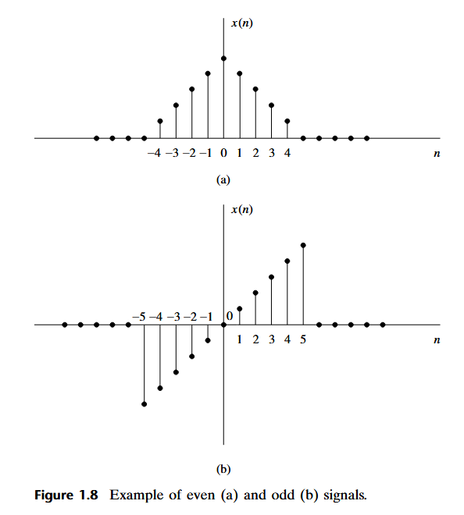  We wish to illustrate that any arbitrary signal can be expressed as the sum of  two signal components, one of which is even and the other odd. The even signal  component is formed by adding x(n) to x(−n) and dividing by 2, that is,  $$x_{e}\left[n\right]=\frac{x\left[n\right]+x[-n]}{2}$$  Clearly, x (n) satisfies the symmetry condition (1.24). Similarly, we form an odd signal component X0 (n) according to the relation:  $$x_{o}\left[n\right]=\frac{x\left[n\right]-x[-n]}{2}$$  Any arbitrary signal can be expressed as  $${x\left[n\right]=x}_{e}\left[n\right]+x_{o}\left[n\right]$$
Sample Problems
 | Find the even and odd part of the function $x[n]=3^{n}$
 | What are the even and odd parts of the function $x\left[n\right]=3e^{\frac{jπn}{5}}$
 | What are the even and odd parts of the function $x\left[n\right]=\{2,-2,6,-2\}$
Periodic and Aperiodic Signals | A signal x[n] is periodic with period $N(N>0)$ if and only if  $x\left(n+N\right)=x\left(n\right)$ for all n.  If there is no value of N that satisfies the equation above, the signal is called non periodic or aperiodic.  Periodic signals are power signal.  N = fundamental period in discrete time. N must be a positive integer.  $ω=$ fundamental angle of frequency or discrete angle of frequency. It is denoted as $ω=2πf$  Frequency is denoted as $f=\frac{K}{N}$
Transformation of the independent variable (time) | A signal x(n) may be shifted in time by replacing the independent variable n by n − k, where k is an integer. If k is a positive integer, the time shift results in a delay of the signal by k units of time. If k is a negative integer, the time shift results in an advance of the signal by |k| units in time.  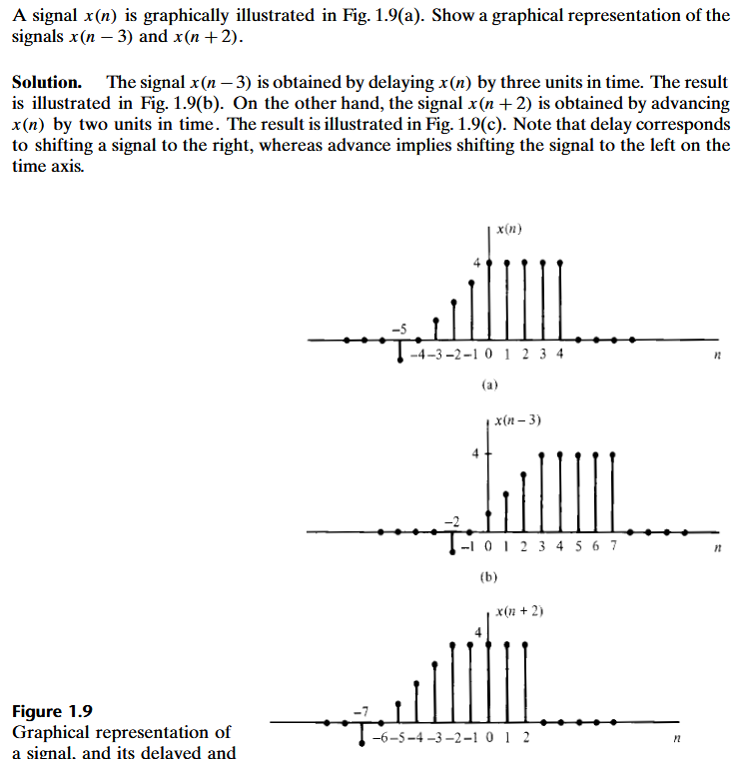
Folding or reflection | Another useful modification of the time base is to replace the independent vari-  able n by −n. The result of this operation is a folding or a reflection of the signal  about the time origin n = 0  Folding x[-n + 2] -> x[-(n-2)]  Solution:  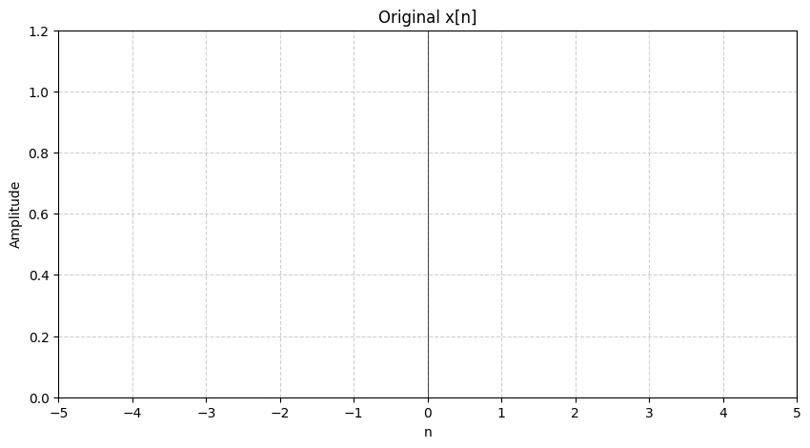  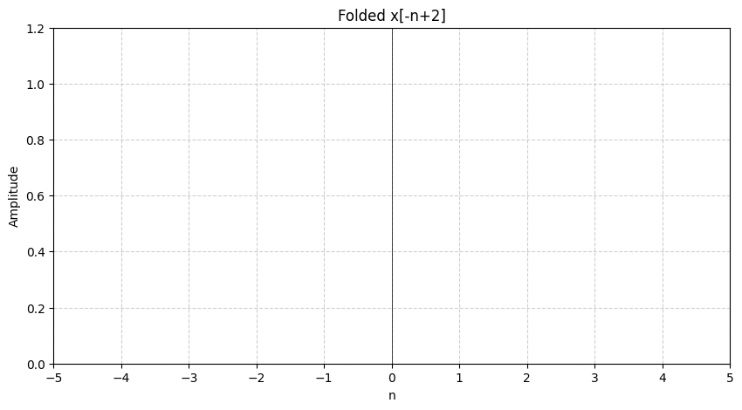  
Time shifting or Down Sampling | A third modification of the independent variable which involves by replacing by $n$by 𝛍n, where 𝛍 is an integer.  If value na naka multiply sa n is:  Integer – compressed  Fraction - stretched  Down Sampling:
Time shifting x[n-k] | Pakanan ang movement
Advance x[n-(-k)] | X[n+k] pa left ang movement
Example: x[n]

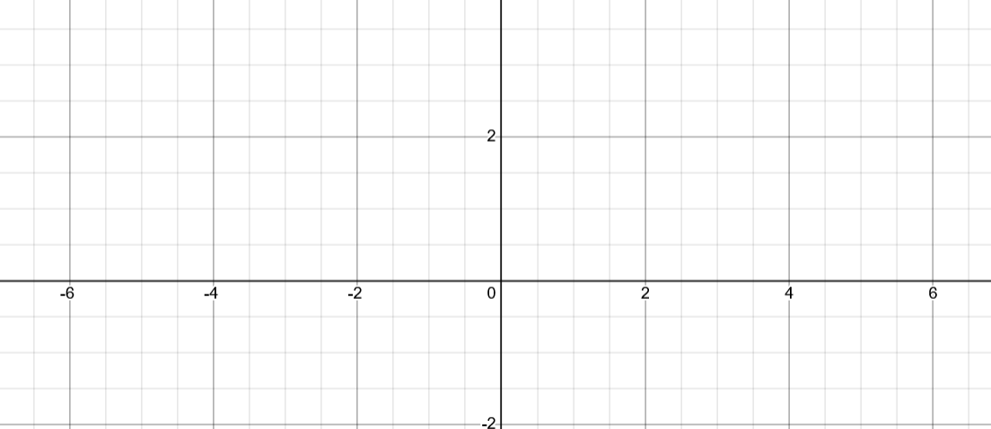

X[n-3]


Input/Output | The input–output description of a discrete-time system consists of a mathematical expression or a rule, which explicitly defines the relation between the input and output signals (input–output relationship). The exact internal structure of the system is either unknown or ignored. Thus the only way to interact with the system is by using its input and output terminals (i.e., the system is assumed to be a “black box” to the user).  Aside from the previous figure and equation, alternatively, we use the notation  $x\left[n\right]\underset{→}{T}y[n]$  which simply means that y(n) is the response of the system $T$to the excitation x(n). The following examples illustrate several different systems.  Determine the response of the following the systems to the input signal  $$x\left[n\right]=\left\{\begin{aligned}\left|n\right| \\ 0 \end{aligned}\right.\begin{matrix} , -3≤n≤3 \\ , otherwise \end{matrix}$$  - $y\left[n\right]=x\left[n\right]$ (identity system)  - $y\left[n\right]=x\left[n-1\right]$ (unit delay system)  - $y\left[n\right]=x\left[n+1\right]$ (unit advance system)  - $y\left[n\right]=\frac{1}{3}\left[x\left[n+1\right]+x\left[n\right\}+x\left[n-1\right]\right]$ (moving average filter)  Solution:  - $y\left[n\right]=x\left[n\right]$ (identity system)  - $y\left[n\right]=x\left[n-1\right]$  - $y\left[n\right]=x\left[n+1\right]$  - $y\left[n\right]=\frac{1}{3}\left[x\left[n+1\right]+x\left[n\right\}+x\left[n-1\right]\right]$
Block Diagram Representation of Discrete-Time Systems | It is useful at this point to introduce a block diagram representation of discrete-time systems. For this purpose we need to define some basic building blocks that can be interconnected to form complex systems.  Adder – a system (adder) that performs the addition of two signal sequence to form another (the sum) sequence, which we denotes as y(n). Note that it’s not necessary to store either one of the sequences in order to perform the addition. In other words, the addition operation is memoryless.  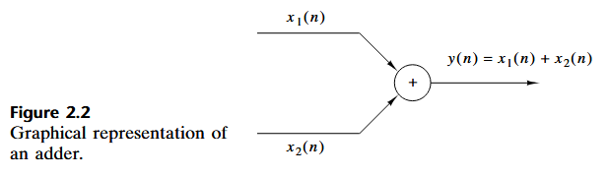  Constant multiplier – Simply represents applying a scale factor on the input x(n). Note that this operation is also memoryless.  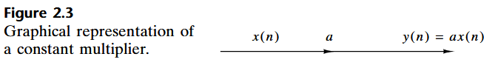  Signal multiplier – the multiplication of two sequences to form another (the product) sequence , denoted in the figure y(n). As in the preceding two cases, we can view themultiplication operation as memoryless.  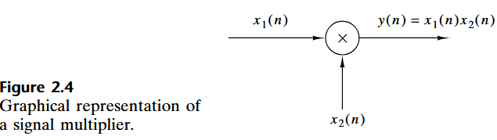  Unit Delay – The unit delay is a special system that simply delays the signal passing through it by one sample. If the input signal is x(n), the output is x(n-1). In fact, the sample x(n-1) is stored in memory at a time n-1 and it is recalled from memory at time n to form:  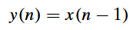  Thus this basic building block requires memory. The use of the symbol z−1 to denote the unit of delay will become apparent when discussing the z-transform.  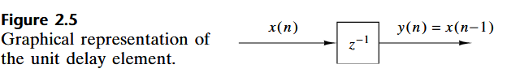  Unit advance element – In contrast to the unit delay, a unit advance moves the input x(n) ahead by 1 sample in time to yield x(n+1). We observe that any such advance is physically impossible in real time, since, in fact, it involves looking into the future of the signal. On the other hand, if we store the signal in the memory of the computer, we can recall any sample at any time. In such a non-real-time application, it is possible to advance the signal x(n) in time.  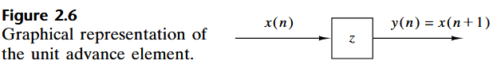
Examples
- Give the input output relation of the given system below.
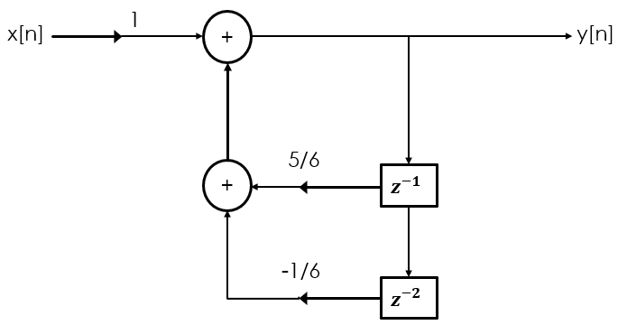

- Draw $y\left[n\right]=\frac{1}{2}y\left[n-1\right]+\frac{1}{3}y\left[n-2\right]+x\left[n\right]+2x\left[n-1\right]$

1
y[n]
+
+
x[n]

1/2
$$z^{-1}$$
2
$$z^{-1}$$

1/3
$$z^{-2}$$

- $y\left[n\right]=\frac{1}{4}y\left[n-1\right]+\frac{1}{2}x\left[n\right]+\frac{1}{2}x[n-1]$

$$y\left[n\right]=\frac{1}{4}y\left[n-1\right]+\frac{1}{2}[x(n)+x(n-1)]$$
$$z^{-1}$$

0.5
+
y[n]
x[n]
+

$$z^{-1}$$

